*Supplementary Material for: Microplastic occurrence after conventional and nanofiltration processes at drinking water treatment plants: preliminary results*

Jean-Sebastien Barbier1*, Rachid Dris1*, Caroline Lecarpentier2, Vivien Raymond2, Karine Delabre2, Sylvie Thibert3, Bruno Tassin1, Johnny Gasperi4

1 Laboratoire eau environnement et systemes urbains (LEESU), Université Paris-Est Créteil, Créteil, France

2 Veolia Eau d’Île de France, Nanterre, France

3 Syndicat des Eaux d’Île de France, Paris, France

4 Laboratoire eau environnement (LEE), Université Gustave Eiffel, Bouguenais, France

**\*Correspondence:**Jean-Sébastien Barbier and Rachid Dris  
[jean-sebastien.barbier@lsce.ipsl.fr](mailto:jean-sebastien.barbier@lsce.ipsl.fr); [rachid.dris@u-pec.fr](mailto:rachid.dris@u-pec.fr)

# Supplementary Material SM 1. Sample Data

See supplementary material files for .csv  
This file contains raw data for each sample : sampling date, microplastic concentration per polymer, rain during the last 24h before sampling (mm), raw water turbidity (NTU or FNU), raw water NH4 (mg/L) and raw water total organic carbon (mg/L)

# Supplementary Material SM 2. Detailed outlet water sampling procedure

## Materials

* 47 mm diameter stainless steel filter holder (Merck Millipore®, ref XX4404700, see Sup. Fig 1. for part details. NB: the O-ring is made of silicone, which was not investigated in this study)
* Vent plug
* Wrench
* Hex key
* 47 mm diameter stainless steel 10 µm mesh filter
* 2 x ¼ inch male to 14 mm plug-in adapter (ex: RS®, ref 3175 14 21, see Sup. Fig 2.)
* 2 x 14 mm diameter PU tubes
* Water meter and appropriate connectors
* Appropriate hydraulic connector(s) for 14 mm tubing at the outlet sampling point
* PTFE tape
* Aluminum foil

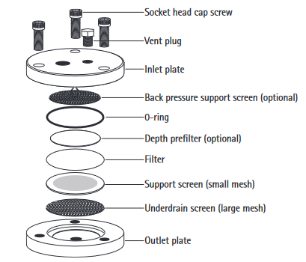

Sup. Fig 1. Filter holder components diagram (source: Merck Millipore User Guide)

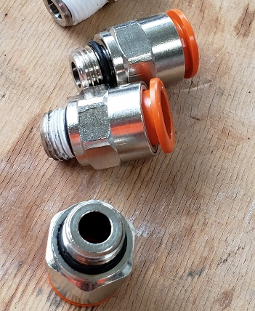Sup. Fig 2. Hydraulic adapters (2 x ¼ inch male to 14 mm plug-in adapter)

## Cleaning procedure

* Disassemble each part of the filter holder (see Fig 1.). No back pressure support screen or depth prefilter were used in this study.
* Remove the sample filter
* Remove PTFE tape from the vent plug
* Clean the device following the instructions from the filter holder user guide
* For optimal microplastics removal, we cleaned each part one more time using 50 % GF/F filtered ethanol in a spray bottle
* After the ethanol has dried up, place a new stainless steel filter. Assemble the filter holder and tighten the head cap screws using the hex key.
* Wrap the filter holder in aluminum foil in order to avoid air contamination until use

## On-site sampling procedure

* Connect a PU tube from the sampling tap and turn on the tap during 2 minutes for flushing
* Remove the filter holder from the aluminum foil
* Wrap the vent plug and the 2 adapters with PTFE tape, use a wrench to screw them tightly to the filter holder
* Connect the first PU tube between the outlet sampling point and the inlet plate adapter
* Connect the second PU tube between the outlet plate adapter and the water meter (see Sup. Fig 3.)
* Record the water meter starting point
* Turn on the water tap. The flow rate used in this study was approximately 300 L/h
* Turn off the water tap after 500 L have been filtered
* Unplug the tubes, use the wrench to remove the adapters.
* Wrap the filter holder in aluminum foil until return to the laboratory
* Follow cleaning procedure (see above) for filter removal and maintenance between samples

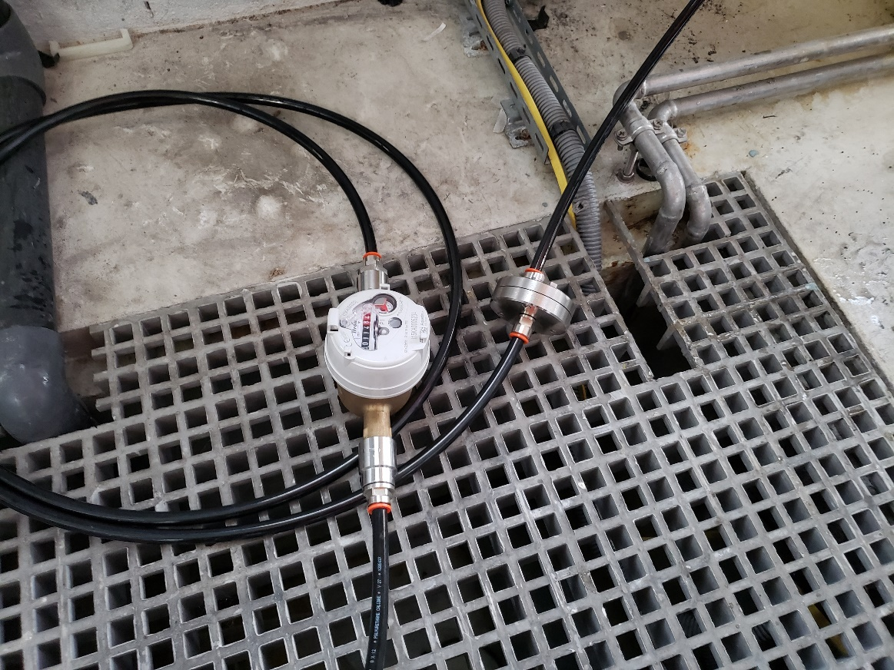Sup. Fig 3. Example of on-site filtration

# Supplementary Material SM 3. Raw MP Data

See supplementary material files for .csv  
This file contains siMPle data for all raw microplastic detected in this study. It contains sample name, matching score (0 to 1 scale; weight of 1 for 1st spectra derivative and 1 for 2nd spectra derivative was used), polymer family (NB: all “polyester” entries detected matched with PET references and were therefore labelled PET in the main paper), size in siMPle pixels (resolution was 25 x 25 µm), size in µm², major dimension (µm), minor dimension (µm), Feret dimension (µm), siMPle volume estimation (µm3, siMPle assumes an ellipsoidal shape for this estimation), mass estimation (ng, siMPle assumes ellipsoidal shape and recorded reference polymer density for this estimation)

# Supplementary Material SM 4. Principal Component Analysis of inlet waters

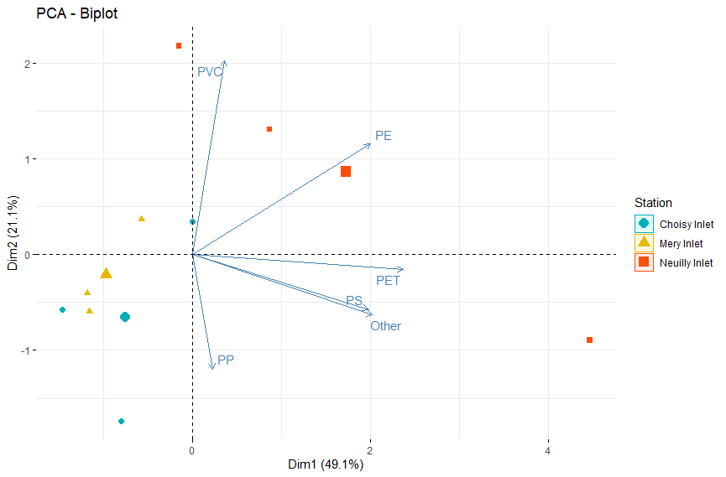   
  
A) Biplot of variable correlation and individuals for the 2 first dimensions of the PCA   
  
Entry variables were concentration per polymer per sample (PE, PP, PVC, PET, PP, PS and other polymers; 3 samples per site: Choisy, Mery and Neuilly inlet). The larger dot represents the barycenter for the associated site. 1st dimension (PC1), is mostly correlated with PE, PET, PS and other polymers. 2nd dimension (PC2) is correlated with PVC and anti-correlated with PP.   
While data is insufficient to draw conclusions, Choisy and Mery inlet samples appear to follow the same trend in the 2 main dimensions. On the other hand, Neuilly inlet samples variations don’t follow the same trend, hinting at differences in plastic sources and/or behavior.   
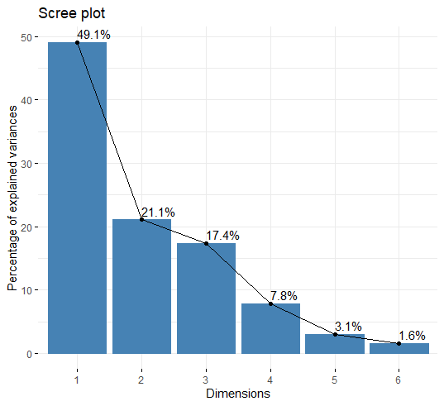  
B) Scree plot of the main dimensions  
  
87.6 % of the total variance in data can be explained with the first 3 dimensions, with 49.1 % for Dim1, 21.1 % for Dim2 and 17.4 % for Dim3.  
  
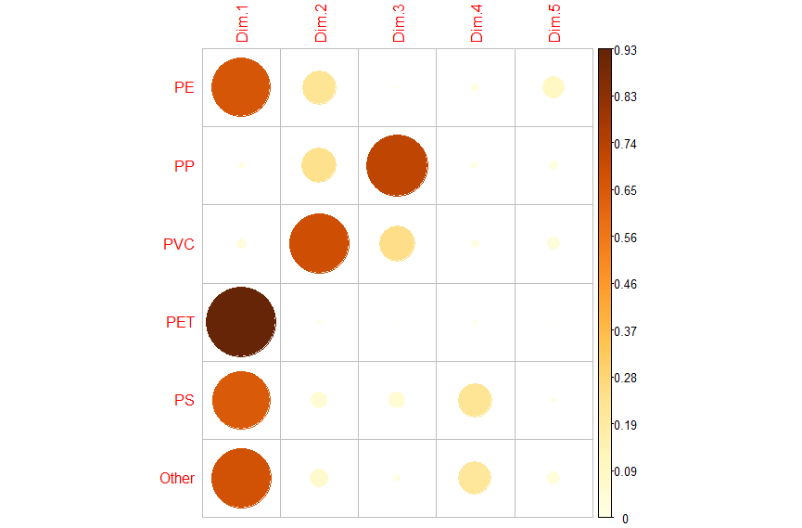  
C) Correlation plot (cos²) of variables for the first 5 PCA dimensions.  
  
Darker and larger dots are means higher cos² of the variable for the associated dimension (0-1 scale on the right). Cos² represents the quality of the representation of a given variable by a dimension.